

THE RVfpga MSc PROJECT

Porting RVfpgaEL2 to a New FPGA Board

INTRODUCTION
RVfpga is a general-purpose System-on-Chip (SoC) design that can be implemented on a wide range of FPGA development boards. When adapting the design to a new board, the main tasks involve modifying the internal peripheral controllers, redefining the external interface connections, and updating the configuration files that handle communication with the target FPGA board.
This document describes the complete process of porting RVfpgaEL2 from the Nexys A7 version to the Nexys Video board. The migration is implemented using Vivado for synthesis and hardware implementation, and the Catapult SDK for uploading and debugging. This serves as a reference workflow for adapting RVfpgaEL2 to other FPGA platforms. The main steps are as follows:
- Design and Constrain Modifications
- Design Synthesis
- Update the OpenOCD Configuration Files
- Simulation and Verification
Some configuration files used in this guide are derived from existing open-source libraries and resources. For certain FPGA boards, additional configuration files may need to be created manually, and such board-specific adaptations are beyond the scope of this document.

- DESIGN AND CONSTRAINTS MODIFICATIONS
Design

The target FPGA board may contain different peripherals or external memory devices compared to the original hardware. In many cases, existing peripheral controllers are not directly compatible, so updates must be made according to both the design requirements and the specific hardware features of the target device.

In this example, the Nexys Video board does not include an accelerometer; it only provides eight LEDs and switches, and requires adaptation to support the onboard OLED display. Within the rvfpganexys module, the signals i_sw_slice[15:8] and gpio_out[15:8] are not connected to any external input or output. During synthesis, these unconnected and nonessential paths will be automatically optimized out.

In the veerwolf_core, the original simple_spi instance (spi2), which was used for accelerometer communication, is replaced with the oled_spi instance (spi2). The wb_intercon module is regenerated to establish the correct connections and address mapping. Detailed information about these changes can be found in Lab06 (wb_intercon) and Lab10 (oled_spi).

Constraints

Constraints should match the top-level interfaces. Standard templates for Digilent FPGA boards can be found at Digilent/digilent-xdc: A collection of Master XDC files for Digilent FPGA and Zynq boards. The signal names in RVfpga differ from the official templates, so modify the constraints file accordingly.

- SYNTHESIS

Refer to Lab05 for more detailed information on the synthesis process.

- UPDATE THE OPENOCD CONFIGURATION FILES

This section outlines the configuration files that you may need to update to support FPGA programming and debugging. Four key files are involved in the porting process:
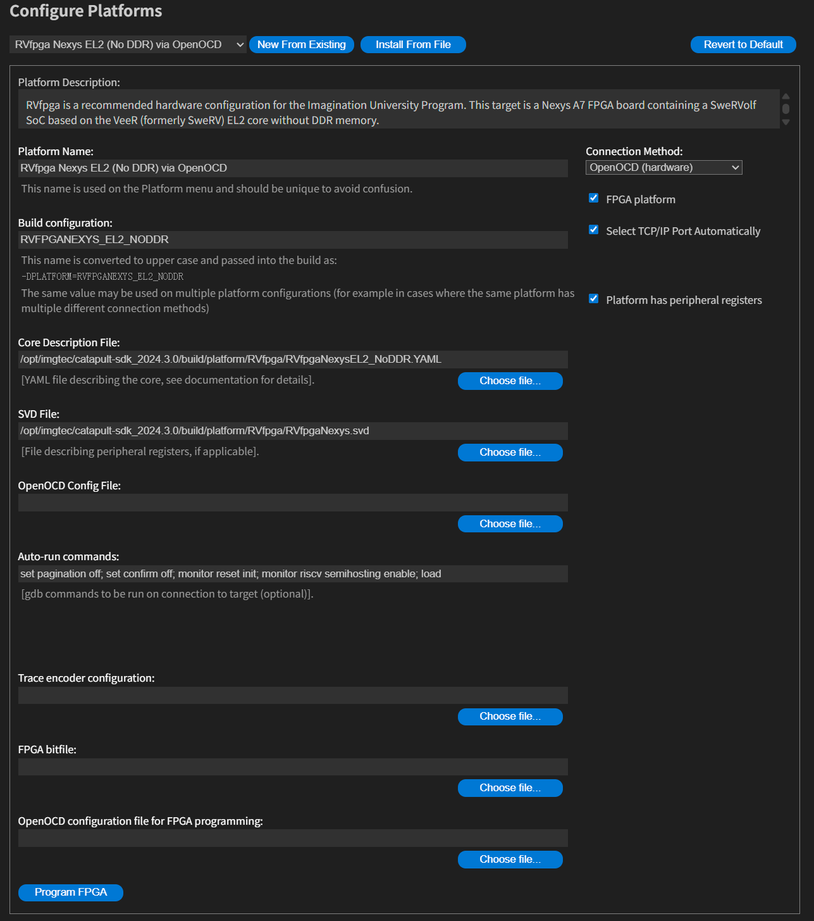
Figure 1. Catapult-SDK Configure Platforms

1. Core Description File - RVfpgaNexysEL2_NoDDR.YAML

This YAML file defines the starting address and size of the main memory regions used by RVfpgaEL2. You only need to modify this file when making changes to the el2_mem module or when using a different DDR memory configuration. You may find it at:
[catapult-sdk]/build/platform/RVfpga\/RVfpgaNexysEL2_NoDDR.YAML

2. SVD File - RVfpgaNexys.svd

The .svd file provides information for the debugger to display user interface labels and details for memory-mapped addresses during debugging. Modifying this file allows the debugger to display the corresponding address and register information in the UI. However, the file appears to be auto-generated by an unavailable script, so manual edits must follow the structure of existing peripherals. In practice, these changes have limited effect, and modification is generally not recommended.

If you wish to see the corresponding memory address hints during debugging, adjust the file path as follows:
[catapult-sdk]/build/platform/RVfpga/RVfpgaNexys.svd

- OpenOCD Config File - RVfpgaNexysVideoEL2_NoDDR_debug.cfg

This file defines communication and memory mapping for the debugging process. The communication configuration is identical to the OpenOCD Configuration File for FPGA Programming, but includes additional sections that describe the address map used by the design. This enables access to specific memory addresses during debugging. If new peripherals are added that use different address mappings, the corresponding configuration entries must be updated.

The file used here is a modified version, with only the communication section changed. The modified file is located at:
[RVfpga_NexysVideo-NoDDR]/NexysVideo_config/RVfpgaNexysVideoEL2_NoDDR_debug.cfg

In Figure 2. Lines 19 to 20 define the main memory address range, while lines 23 to 28 specify the peripheral mapping addresses, which should correspond to the configuration used in:
[RVfpga_NexysVideo-NoDDR]\src\VeeRwolf\Interconnect\WishboneInterconnect

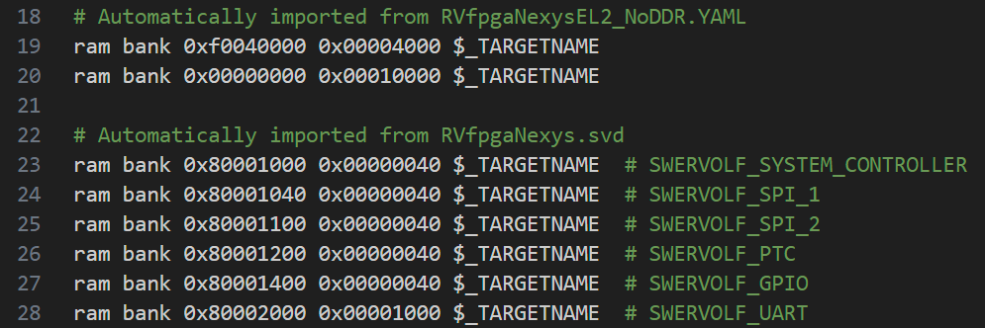
Figure 2. RVfpgaNexysVideoEL2_NoDDR_debug.cfg

- FPGA Bitfile - rvfpganexys.bit

Fill in your bitstream file path. The bitfile location and generation process are described in Lab05.

5. OpenOCD Configuration File for FPGA Programming - RVfpgaNexysVideoEL2_NoDDR.cfg

RVfpgaEL2 uses the Catapult SDK for programming and debugging, which relies on OpenOCD for these operations. When programming the FPGA, the configuration must include definitions for FTDI adapter setup, target device setup, bitstream handling, and execution flow, as illustrated in the following figure. You can find this file at:
[RVfpga_NexysVideo-NoDDR]\NexysVideo_config\RVfpgaNexysVideoEL2_NoDDR.cfg

Using existing and verified configuration files is often more efficient and reliable. The communication section used in this example comes from riscv-openocd/tcl/board at riscv · riscv-collab/riscv-openocd, and additional configuration files for other board are also provided by the VeeRwolf project at VeeRwolf/data at main · chipsalliance/VeeRwolf.

- SIMULATION AND VERIFICATION
If any design files were added or removed during the previous steps, make sure to update the simulation file list accordingly.
The relevant configuration file is located at:
RVfpga/RVfpgaEL2/RVfpga_NexysVideo-NoDDR/Simulators/verilatorSIM_Trace/rvfpgasim.vc

You may need to modify the Verilog include paths and file references in this file.
For example, if a new peripheral such as the OLED SPI module was added, include its path as shown below:

Add or remove file entries as needed to match the updated project structure, include new files path as shown below:

